



**Process Design Document (PDD)**

**<Name of Project>**



© 2005–2019 UiPath. All rights reserved.

**NOTE:**

This version of the document and its current content is meant to serve as an example for business users (e.g. process SME) and it is intended to help with the creation of the process design documentation for RPA.

The current example`s content is fictive or adjusted to remove real confidential data and it should not be replicated to the automation of other business processes. All the process steps and screenshots in the PDD should be captured entirely from scratch and included here for the automation of the process is scope.

The list of examples is not exhaustive. Additional entries may be added or removed, case by case, as required to provide relevant data for RPA.

**Document History**

|  |  |  |  |  |  |  |
| --- | --- | --- | --- | --- | --- | --- |
| Date | Version | Role | Name | Organization (Dept.) | Function | Comments |
| 01.02.2018 | 1.0 | Author | Maria Ionescu | *CoE* | *Business Analyst* | Created document v 1.0 |
| 03.02.2018 | 2.0 | SME | Andrew Lloyd | *Finance & Accounting* | *Business Process Owner* | Updated according to SME feedback |
| 04.02.2018 | 3.0 |  | James Peterson | *CoE* | *Dev/RPA Solution Architect* | Updated according to Solutions Architect feedback |

**Document Approval Flow**

|  |  |  |  |  |  |
| --- | --- | --- | --- | --- | --- |
| Version | Flow | Role | Name | Organization (Dept.) | Signature and Date: |
| **4.0** | **Document prepared by** | *Business Analyst* | Maria Ionescu | *CoE* |  |
| **4.0** | **Document Approved by:** | *Head of Accounting* | Ion Popescu | *Finance & Accounting* |  |
| **4.0** | **Document Approved by:** | *CoE Manager* | John Smith | *CoE* |  |

**Table of Contents**

**I. Introduction**

I.1 Purpose of the Document

I.2 Objectives

I.3 Key Contacts

I.4 Minimum Prerequisites for Automation

**II. As-Is Process Description**

II.1 Process Overview

II.2 Applications Used in the Process

II.3 As-Is Process Map

II.4 Detailed As-Is Process Steps

II.5 Input Data Description

**III. To-Be Process Description**

III.1 To-Be Detailed Process Map

III.2 Parallel Initiatives / Overlap (if applicable)

III.3 In Scope for RPA

III.4 Out of Scope for RPA

III.5 Business Exceptions Handling

# **Introduction**

## I.1 Purpose of the Document

The Process Definition Document outlines the business process chosen for automation using UiPath Robotic Process Automation (RPA) technology.

The document describes the sequence of steps performed as part of the business process, the conditions and rules of the process prior to automation and how they are envisioned to work after automating it, partly or entirely. This specifications document serves as a base for developers, providing them the details required for applying robotic automation to the selected business process.

## I.2 Objectives

The process that has been selected for RPA is part of the larger project Accounts Receivable conducted within the ACME Systems Inc, Finance and Accounting department.

The business objectives and benefits expected by the Business Process Owner after automation of the selected business process are:

* *Reduce processing time per item by 80 %*
* *Better Monitoring of the overall activity by using the logs provided by the robots*

## I.3 Key Contacts

The specifications document includes concise and complete requirements of the business process and it is built based on the inputs provided by the process **Subject Matter Expert (SME)/ Process Owner.**

The **Process Owner** is expected **to review it and provide signoff for accuracy** and completion of the steps, context, impact and complete set of process exceptions. The names have to be included in the table below.

|  |  |  |  |
| --- | --- | --- | --- |
| Role | Name | Contact details  (email, phone number) | Notes |
| Process SME | Andrew Lloyd | [andrew.lloyd@acme-test.com](mailto:andrew.lloyd@acme-test.com) | Point of contact for questions related to process details & exceptions |
| Process Reviewer | John McDonald | john.mcdonald@acme-test.com | Point of contact for questions related to process details & exceptions |
| Process Owner/ Approver for production | Ion Popescu | [ion.popescu@acme-test.com](mailto:ion.popescu@acme-test.com) | Escalations, Delays etc. |

## I.4 Minimum Prerequisites for Automation

1. Filled in Process Design Document
2. Test Data to support development
3. User access and user accounts creations (licenses, permissions, restrictions to create accounts for robots)
4. Credentials (user ID and password) required to logon to machines and applications
5. Dependencies with other projects on the same environment

# **As-Is Process Description**

## II.1 Process Overview

General information about the process selected for RPA prior to automation.

|  |  |  |
| --- | --- | --- |
| # | Item | Description |
| 1 | **Process full name** | Order to Cash |
| 2 | **Process Area** | Finance |
| 3 | **Department** | Accounts Receivable |
| 4 | **Process short description**  (operation, activity, outcome) | The AR department receives daily Purchase Orders from clients. Client and order data is processed and entered in the ERP system, after which the Sales Order is generated and sent back to the client. |
| 5 | **Role(s) required for performing the process** | Accounts Receivable |
| 6 | **Process schedule and frequency** | Daily, Monday to Friday, 9 am – 6 pm |
| 7 | **# of items processes /reference period** | ~450/ day business as usual |
| 8 | **Average handling time per item** | 3 min |
| 9 | **Peak period (s)** | Beginning of every week, when weekend orders need to be processed |
| 10 | **Transaction Volume During Peak period** | 600 |
| 11 | **Total # of FTEs supporting this activity** | 10 |
| 12 | **Expected increase of volume in the next reference period** | Volumes will increase with 20% |
| 13 | **Level of exception rate** | No expected exceptions |
| 14 | **Input data** | Email containing Purchase Order (PDF) from client |
| 15 | **Output data** | Sales order generated from ERP |

*\*Add more rows to the table to include relevant data for the automation process. No fields should be left empty. Use “n/a” for the items that don`t apply to the selected business process.*

## II.2. Applications Used in the Process

The table includes a comprehensive list all the applications that are used as part of the process automated, at various steps in the flow.

|  |  |  |  |  |  |
| --- | --- | --- | --- | --- | --- |
| # | Application name & version | System  Language | Thin/Thick Client | Environment/  Access method | Comments |
| 1 | Outlook | EN | Thick Client | Web Browser | Task management |
| 2 | ERP | EN | Thick Client | Windows Application |  |
| 3 | Excel | EN | Thick Client | Windows Application | For master data |

*\*Add more rows to the table to include the complete list of applications.*

## II.3 As-Is Process Map

**High Level As-Is Process Map:**

This chapter depicts the As Is business process at a High Level to enable developers to have a high-level understanding of the current process.

**Detailed As-Is Process Map:**

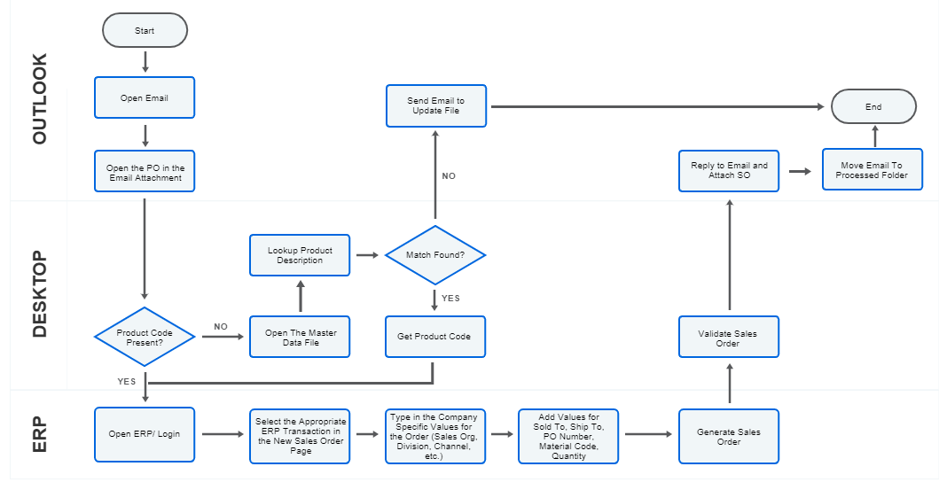

## II.4 Detailed As-Is Process Steps

This chapter depicts the As-Is business process in detail to enable the Developer to build the automated process.

|  |  |  |  |  |  |  |
| --- | --- | --- | --- | --- | --- | --- |
|  | Detailed As-Is Process Steps | | | | | |
| Step | Input | Description | Details (Screen/ Document/ Video recording Index) | Exception Handling | Possible Actions | Business Rules Library Index |

*See doc attached*



# **To-Be Process Description**

This chapter highlights the expected design of the business process after automation.

## III.1 To-Be Detailed Process Map

*Highlight Bot interventions/ to-be automated steps with different legend/ icon (orange)*

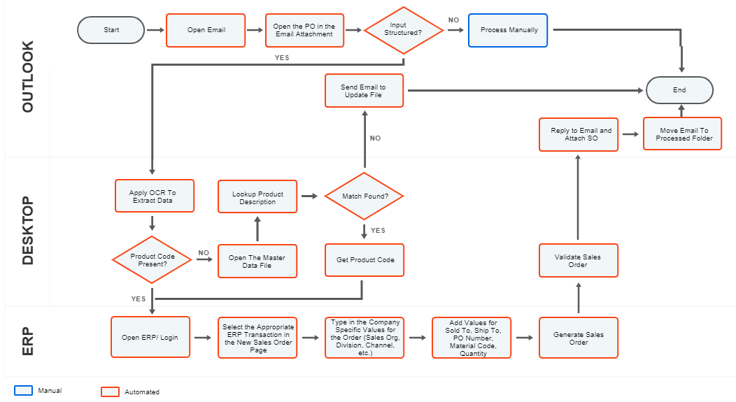*\*Mention below if process improvements were performed on the To-Be design and detail them*

## III.5 Business Exceptions Handling

The Business Process Owner and Business Analysts are expected to document below all the business exceptions identified in the automation process. These can be classified as:

|  |  |
| --- | --- |
| Known | Unknown |
| Previously encountered. A scenario is defined with clear actions and workarounds for each case. | New situation never encountered before. It can be caused by external factors. Cannot be predicted with precision, however if it occurs, it must be communicated to an authorized person for evaluation. |

#### Known Exceptions

The table below reflects all the business process exceptions captured during the process evaluation and documentation. These are **known exceptions,** met in practice before. For each of these exceptions, define a corresponding expected action that the robot should complete if it encounters the exception.

|  |  |  |  |  |
| --- | --- | --- | --- | --- |
| **BE #** | **Exception name** | **Step** | **Parameters** | **Action to be taken** |
| 1 | Product out of stock | n/a | Product code | Ignore error, press the Continue button, fill in the data and Save. |

#### Unknown Exceptions

For all the other **unanticipated or unknown business (process) exceptions**, the robot should:

Send an email notification at [exceptions@acme-test.com](mailto:exceptions@acme-test.com) and error message screenshot attached.